**No Objection Certificate (Citizen)**

Table of Contents

1. Introduction……………………………………………………………………………………………………………………………………….. 3

1.1Purpose…………………………………………………………………………………………………………………………………………….. 3

2. Citizen Module…………………………………………………………………………………………………………………………………… 3

# 1. Introduction

# 1.1Purpose

This Help Document guides the intended Noc user how to manage and fill various noc forms and complete the respective requirements.

# 2. Citizen Module

1. Citizen first login into SSO by using SSO id and password.

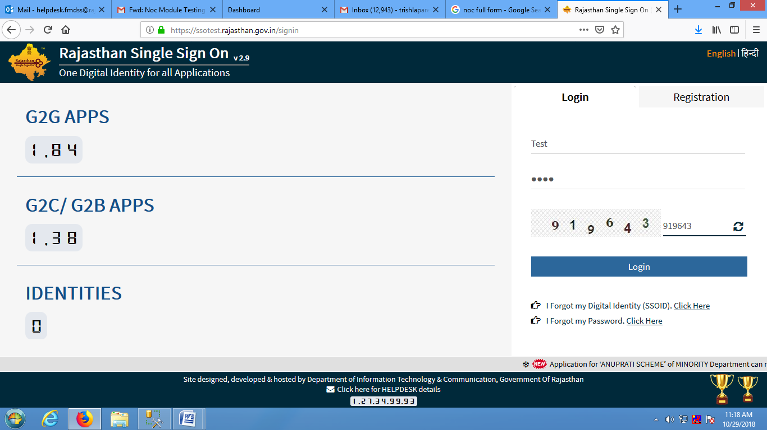

1. After login into SSO, Citizen Dashboard will be open then citizen will click on Clearance and Nocs ->Non Forest Land outside Pas.
2. Noc dashboard will open, Citizen will click on permission for which he/she want to apply for noc permission.(If any permission is not mention in dashboard for which citizen want to apply then citizen will click on Other permission.)
3. For permission, Citizen will click on View Details.

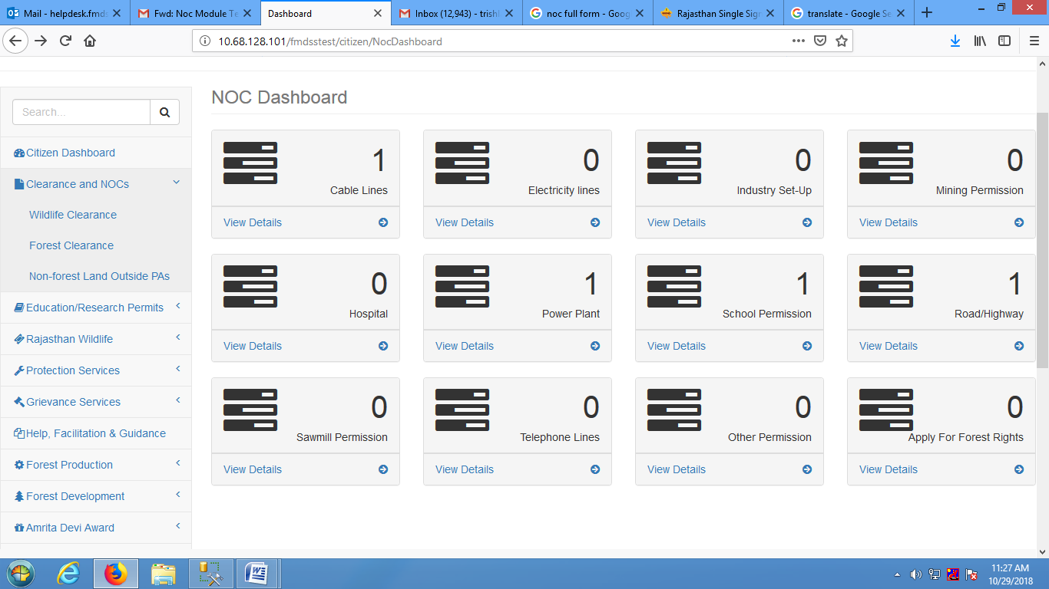

1. Selected Noc page will be open, Citizen will click on Apply button (For applying for new permission).Citizen can also check the existing apply noc status in dashboard.

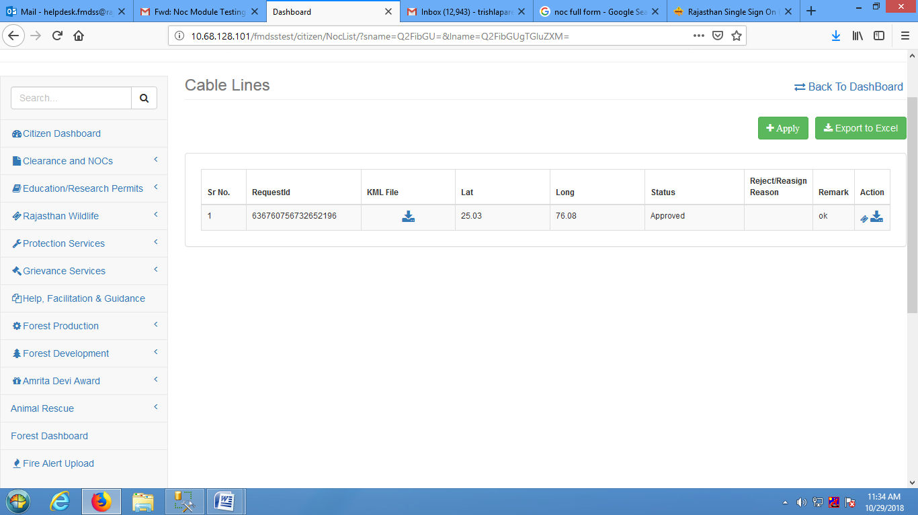

1. After clicking on Apply button, selected Noc form will open.

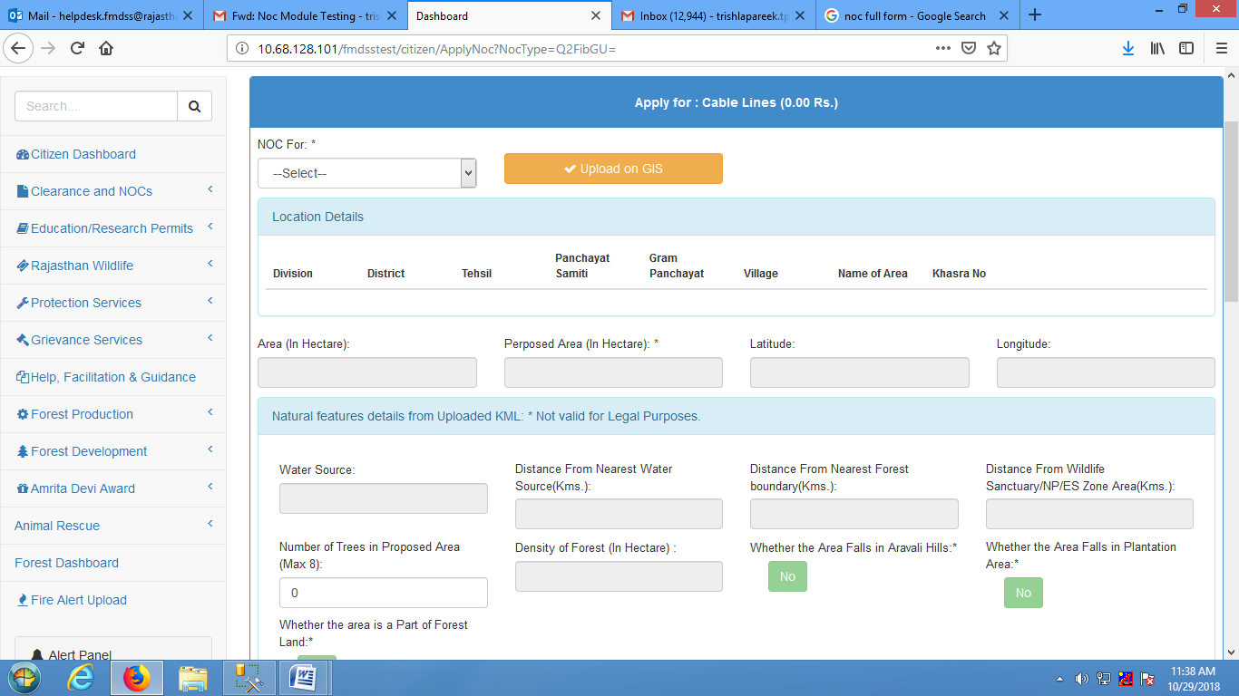

1. Citizen will select Noc for (individual, organization, community) from the drop down menu and then upload gis for the selected option by clicking on upload on Gis button.

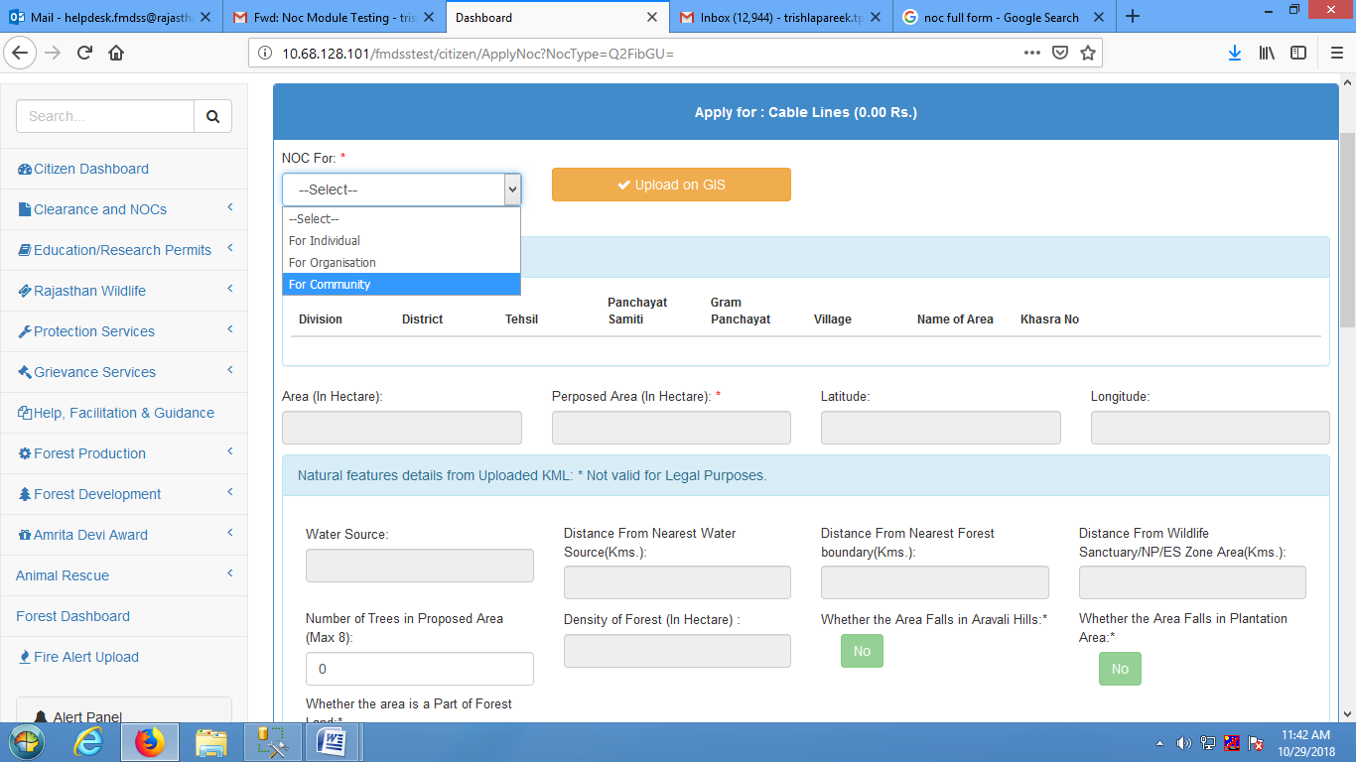

1. For uploading gis, citizen will click on place in map where citizen want to apply for noc(Zoom the area where citizen want to apply for Noc) and then click on draw Aoi button .
2. Citizen will draw Aoi for noc applying area.
3. Citizen can also upload Aoi(if citizen have already ) by clicking on upload aoi button.

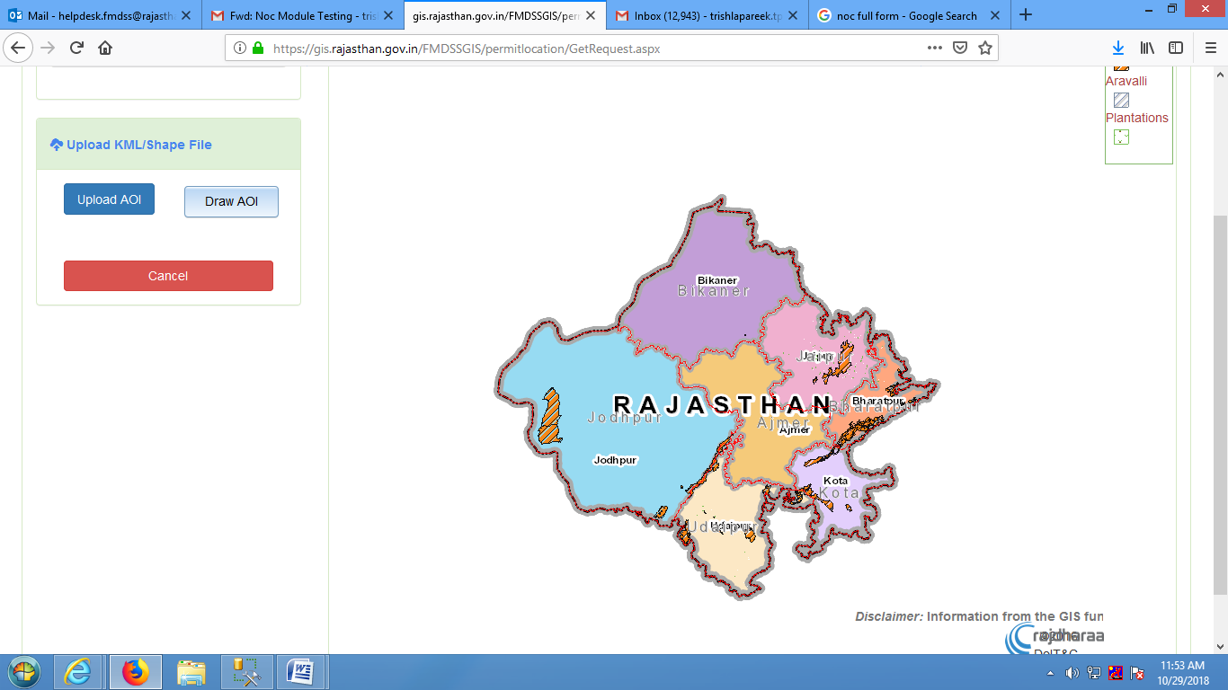

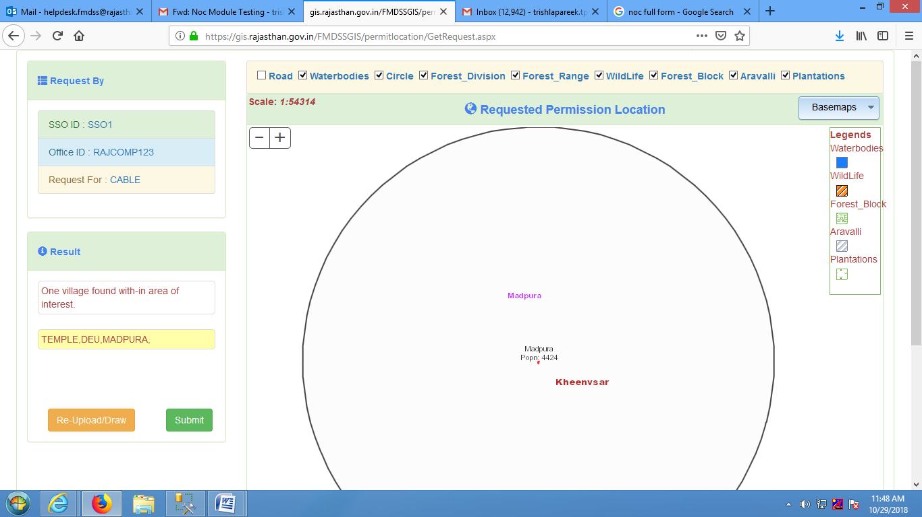

Note: After drawing the area for noc permission, Process will take time, please don’t refresh the page.

1. Citizen will click on Submit button.
2. Clicks can also Re-upload/Draw the noc permission area by clicking on re-upload/draw button.
3. After uploading /Drawing the gis, all the necessary information will automatically uploaded in location details grid .
4. If citizen apply for other permission then citizen will also enter other permission name in other permission text box.

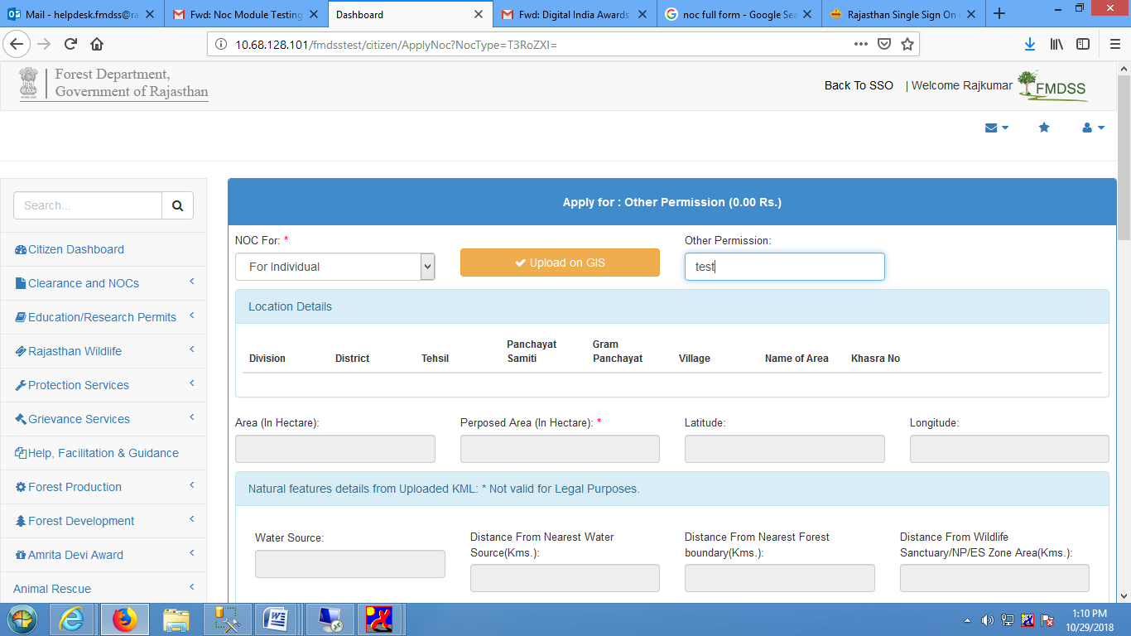

1. .Citizen will enter Khasra no in location details grid .

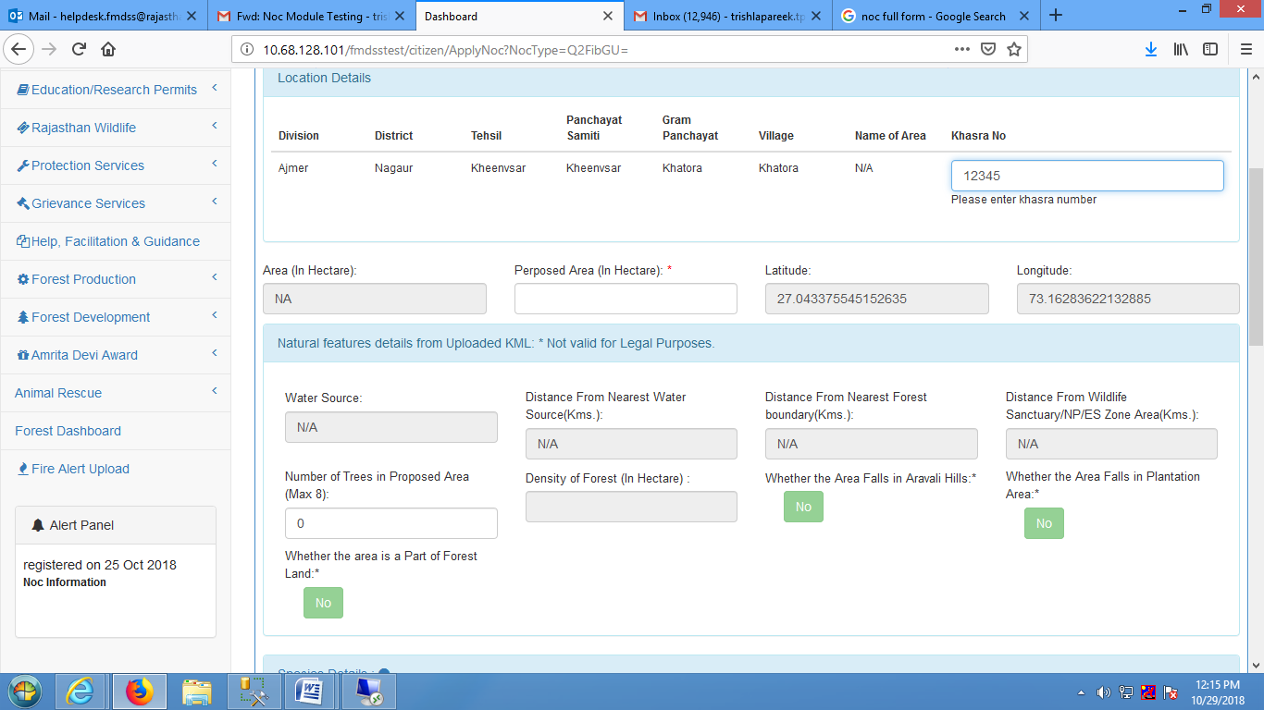

1. After entering khasra number, Citizen will enter Proposed Area (In Hectare) in Proposed Area (In Hectare) text box.

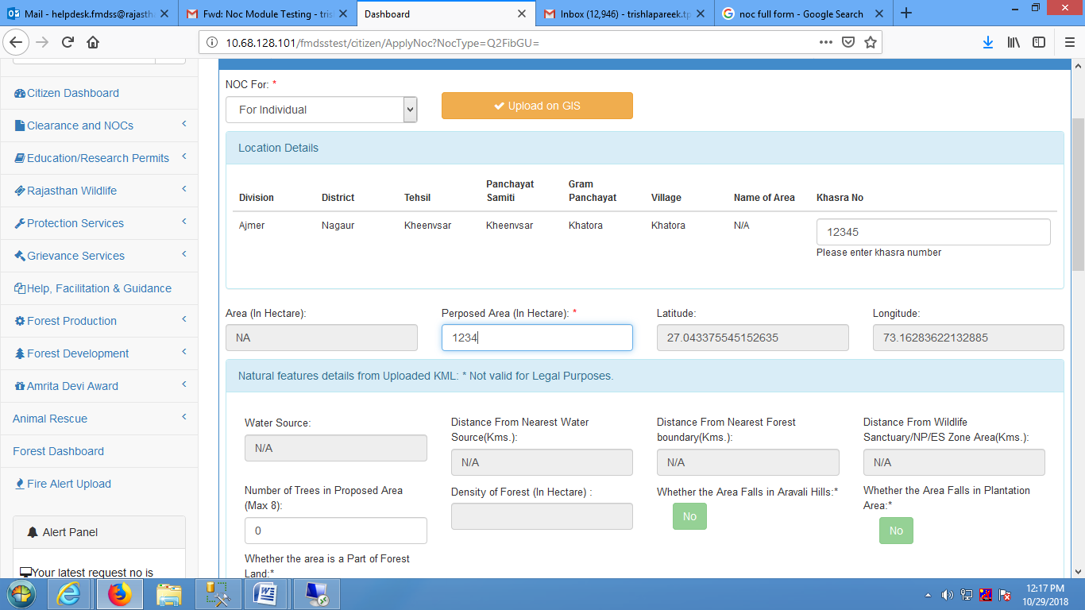

1. In Nature features details from uploaded Kml grid, Citizen will enter Number of trees in proposed area.(Citizen can enter maximum 8 tree).

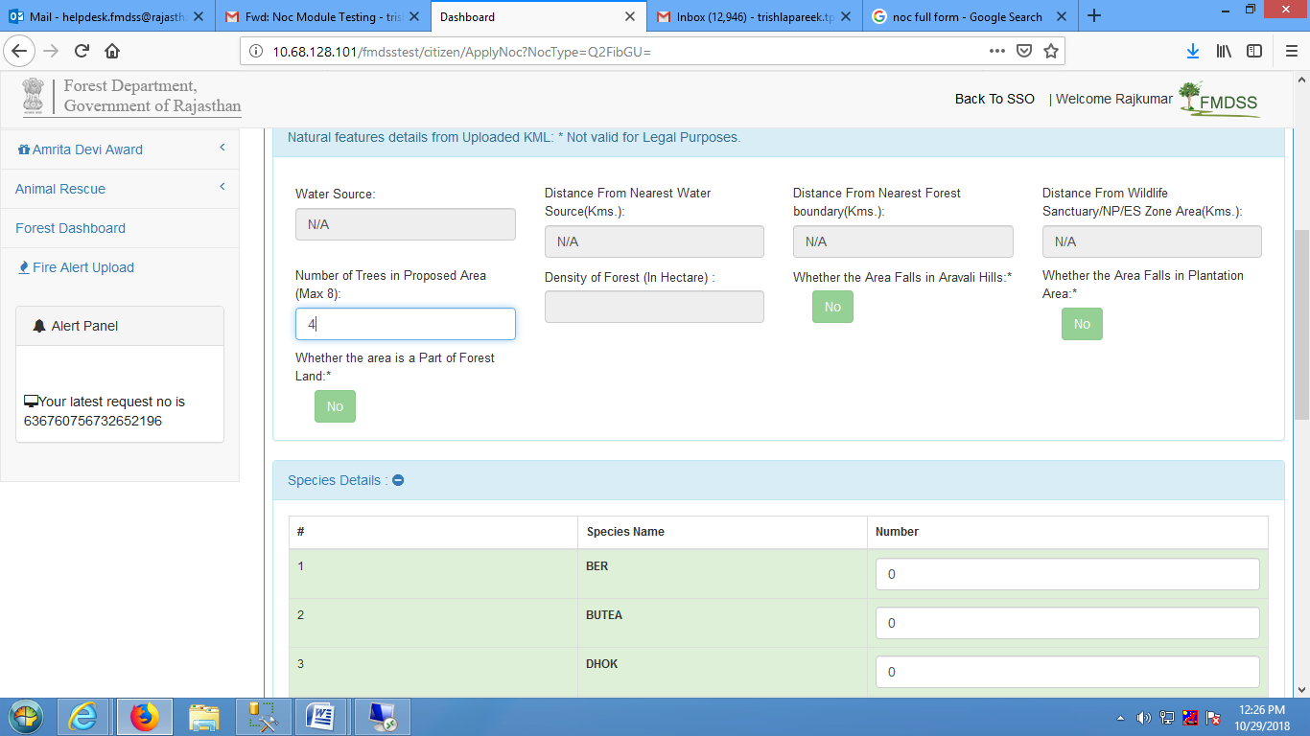

1. In species details grid, citizen will enter Species number in species number text box for species name.
2. Citizen will upload revenue record, revenue map details project report.
3. Citizen will select yes if Revenue Map-Signed By Tehsildar otherwise citizen will select no radio button.
4. Citizen will enter project description in project description text box.
5. After entering project description, citizen will click on submit button.
6. If citizen want to reset the form then citizen will click on reset button.
7. If citizen want to cancel the form then citizen will click on cancel button.

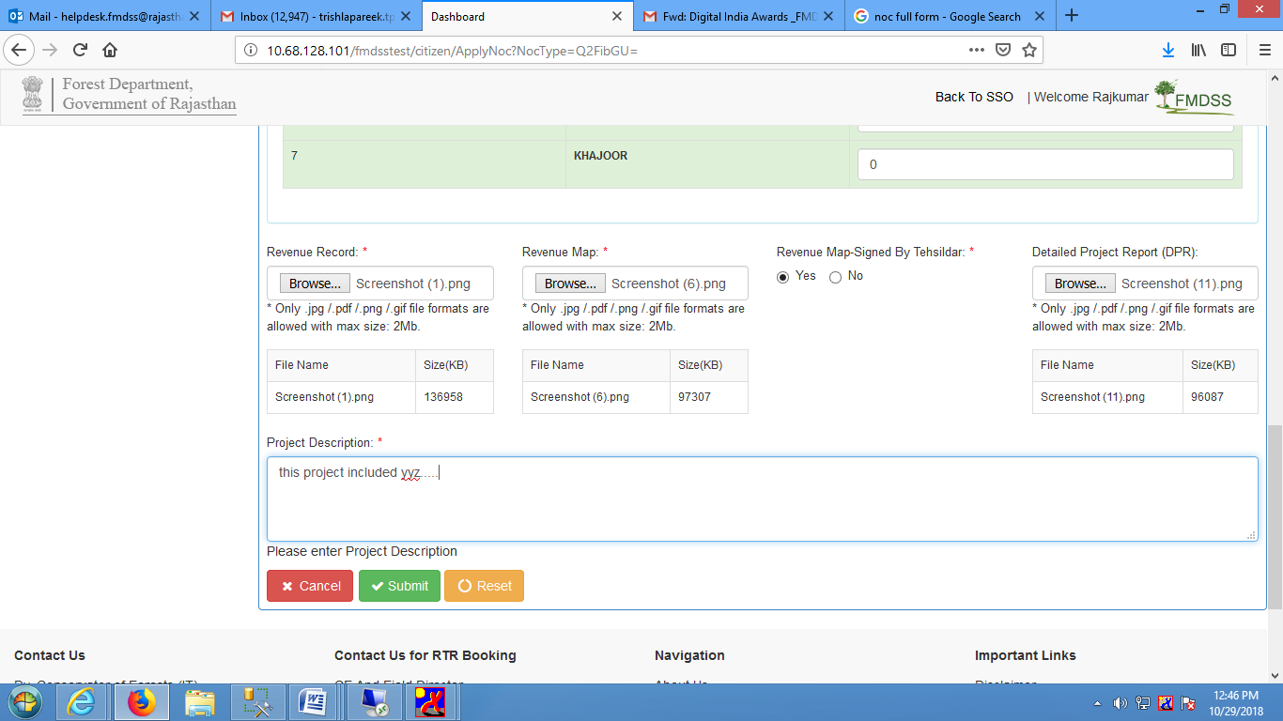

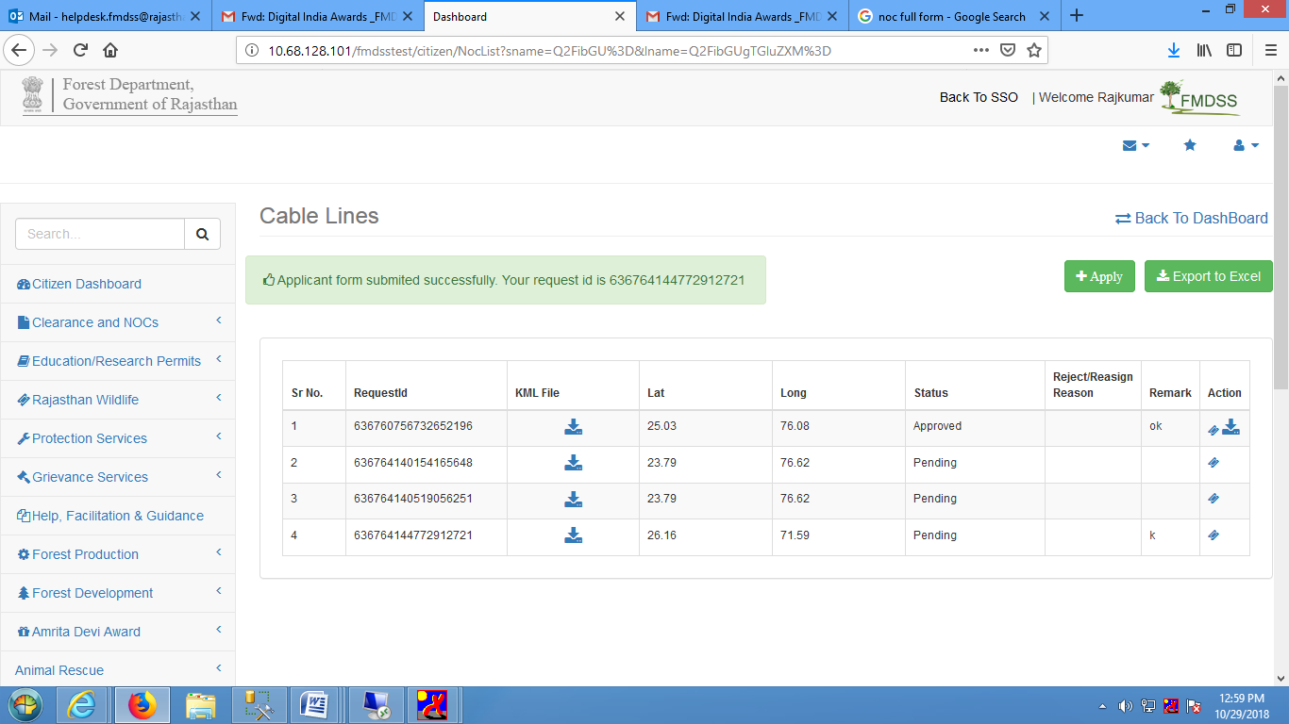

Note: For each and every step citizen will receive Sms/email .

1. After submitting the noc form ,Noc form will successfully submitted message will generate in citizen dashboard with request id .